Ideation Phase Empathize & Discover

Date | 3 December 2025
Team ID
Project Name | Medifolio - Doctor Appointment Booking System
Maximum Marks | 4 Marks

Empathy Map Canvas:

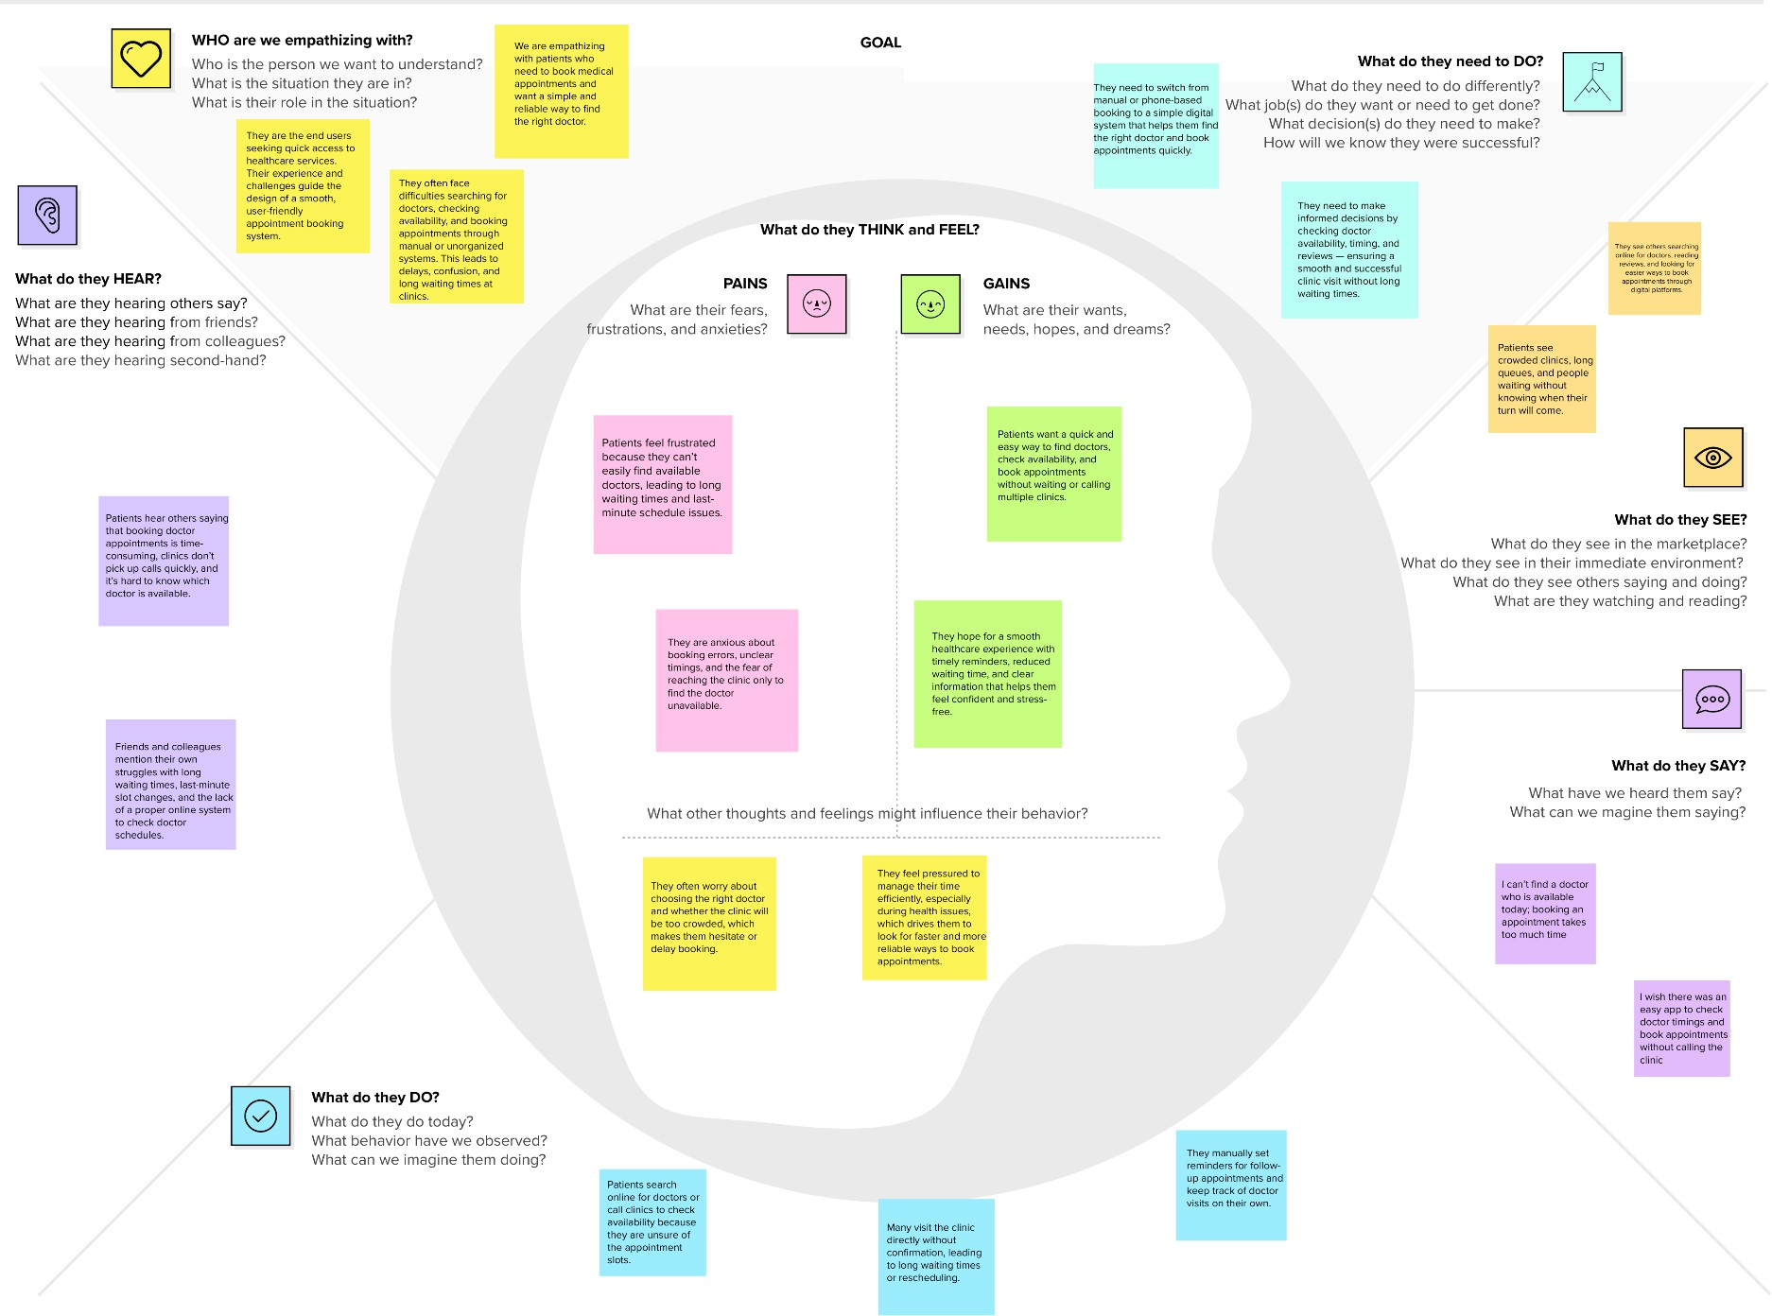

Understand the needs, frustrations, and behaviors of patients who are trying to find the right doctor, check availability, and book appointments easily through a digital platform like Medifolio.

